Z-HEALTH proposal
HORIZON-HLTH-2026-01-STAYHLTH-02: Behavioural interventions as primary prevention for Non-Communicable Diseases (NCDs) among young people

Cluster 1 Health – Destination: Staying healthy in a rapidly changing society
RIA – expected EU contribution: 9-10 million EUR – two projects funded
Cumulative threshold: 12 (4 each criterion)
Opening: 10 Feb 2026 – Deadline: 16 April 2026

Partners
Universities: | Public Health Institutes | Others
- Imperial College London (UK)  - New York University (US)  - University of Cologne (DE)  - Amsterdam UMC (NL) | - Norway (NO)  - Slovenia (SI)  - Germany (DE)  - Basque Country (ES)*  - North Macedonia (MK)*  - Ukraine (UA)* | - EuroHealthNet (BE)  - Isinnova (IT)  - Choice Foundation (SE)*  - European Medical Students’ Association (BE)*  - International Youth Health Organisation (SI)*  - PRESS (NO)*  - BGF Institute (DE)*

Proposal structure
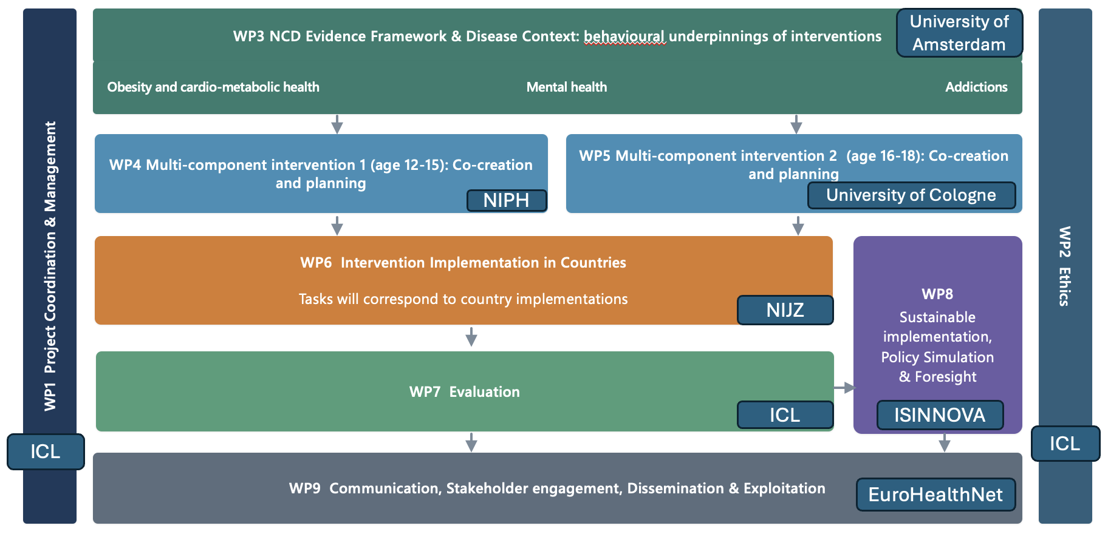

Z-HEALTH: an overview
Z-HEALTH — Health in the Digital Generation — is a multi-country Research and Innovation Action that will evaluate, at scale and across diverse European contexts, the effectiveness of evidence-based behavioural interventions for preventing and reducing the burden of obesity, mental health diseases, and addictions in young people aged 12 to 25. It does so by targeting the shared modifiable causal pathway — the digital habit-formation process — through a pre-specified architecture of four complementary intervention families.
The unifying logic model follows a habit forming pathway:
Environments → Exposure → Repetition/automaticity → Habit formation → Stabilisation.
Interventions enter at different points in this causal chain, constituting four complementary families: (G1) Exposure shaping — preventing habit formation by reducing harmful digital cues (defaults, marketing restrictions); (G2) Friction and interruption — slowing automatic repetition through speed bumps (quiet hours, age gates, cool-off periods); (G3) Agency scaffolding — rebuilding routines via self-regulation supports and feedback (wearables, goal-setting, commitment devices); (G4) Identity and norm stabilisation — locking in gains through peer norms, co-created identities and autonomy-framed inoculation. No single family is sufficient. Z-HEALTH will be the first project to implement all four families simultaneously within the same theoretical framework, across multiple countries and NCD domains.

The Z-HEALTH Habit Pathway
ENVIRONMENTS | EXPOSURE | REPETITION / AUTOMATICITY | HABIT FORMATION | STABILISATION (identity/norms)
Digital, social, institutional | Algorithms, marketing, misinformation | Fast, frictionless, high-frequency | Routine, automatic, rewarding | Peer norms, identity, social signals
G1: Exposure shaping | G2: Friction & interruption | G3: Agency scaffolding | G4: Identity / norm stabilisation | Policy uptake & scale-out
The Z-HEALTH habit pathway and corresponding intervention families
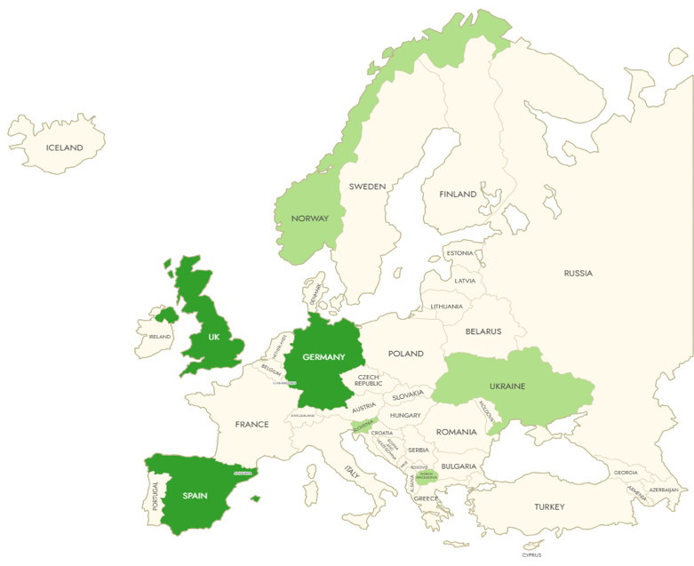

The G1–G4 intervention framework

The G1–G4 framework is the primary organising architecture of Z-HEALTH. Every work package, every study design, and every partner role is structured around these four intervention families, applied across all three disease conditions.

The framework is not new in concept — it synthesises Miraldo's bundling logic, Verplanken's habit discontinuity hypothesis, and the growing literature on structural versus empowerment approaches to behaviour change — but Z-HEALTH is the first project to operationalise all four families simultaneously across multiple NCDs, multiple countries, and multiple life-stage windows.

The Z-HEALTH habit pathway and corresponding intervention families

 | G1 — Exposure Shaping Prevent habits forming by reducing harmful digital cues | G2 — Friction & Interruption Slow automatic repetition through design speed-bumps | G3 — Agency Scaffolding Rebuild routines via self-regulation, feedback, tools | G4 — Identity/Norm Stabilisation Lock in gains through peer norms and co-created identities
Agency required | None (structural) | Low (design nudge) | Moderate (self-regulation) | High (identity/social)
Obesity | UPF marketing restrictions (DSA natural experiments); front-of-pack label defaults; school food environment redesign; smartphone ban evaluation → dietary behaviour | Cafeteria choice architecture (default healthy options); checkout friction in food delivery apps; quiet hours reducing late-night snacking cues | Wearable dietary + PA self-monitoring; food transparency apps (Yuka, Open Food Facts); goal-setting + implementation intentions; incentive/commitment devices | Peer norm reinforcement for healthy food choices; prebunking/inoculation against UPF marketing manipulation; co-created food norms with youth cohorts
Mental Health Diseases | Platform sleep-mode defaults; notification batch architecture; smartphone/social media ban evaluation → sleep quality, depression/anxiety; pagination disrupting body-image social comparison | Screen-time self-monitoring + CBT-I combined package; platform sleep-mode tools vs. third-party blockers (Opal RCT); once-daily notification batching | Computerised CBT (cCBT) for anxiety/depression; wearable sleep monitoring + feedback; mindfulness apps (validated protocols); transition-timed CBT-I deployment | Co-created mental health help-seeking norms; inoculation against social comparison and body-image triggers; peer support network design
Addictions | Gambling/vaping advertising restriction evaluation (DSA/AVMSD compliance across ≥3 EU countries); age-gate enforcement at digital point of exposure; influencer content regulation | Mandatory cool-off/reflection prompts in gambling apps; temporary self-exclusion tools; vaping device usage friction; reduced autoplay in addiction-promoting content | e-Brief interventions (e-BI) + personalised normative feedback for alcohol (ages 18–25; Kaner et al. Cochrane base); digital CBT for substance use; vaping/gaming self-monitoring | Peer norm campaigns against vaping/gambling initiation; identity-based prebunking against addiction marketing; community-level norm activation
G1–G4 intervention families mapped across the three disease conditions. All interventions are evidence-based at TRL ≥5 at project entry. Full TRL table in Section 1.1.4.

WP4: Intervention package 1 - Early to late adolescence |  | WP5: Intervention package 2 - Transition to tertiary education or work
Age group | 12-18 | 19-25
Key transition | From early to late adolescence. | From secondary school to tertiary education or work. Transition to independent living.
Setting | Lower and/or upper secondary schools, depending on organisation of educational system in relevant countries.  Interventions will be implemented in schools, although they may not apply, or not in the same way, to all classes.  Interventions will also be deployed at the individual level. | Two options can be considered:  i. intervention in tertiary education or workplace settings;  ii. intervention at the end of the secondary school cycle, to prepare young people for the coming transition.
Actions involved | Class-based activities; changes in school environment; resources and services for individual use. The intervention approach will be consistent with WHO’s guidelines on Health Promoting Schools, and with EuroHealthNet’s Schools4Health programme. Inclusiveness and sustainability will be key pillars of the intervention approach. | Individual-based and group-based learning, online and in physical settings; use of behavioural monitoring devices; physical and digital environment changes, possibly in tertiary education and/or employment settings.
Countries | Norway, Slovenia, Macedonia, Ukraine | Spain, UK. Germany
Intervention domains
1. Health and digital literacy  Co-creation of health and digital literacy programme with youth and relevant local stakeholders. Involvement of school health services and community nurses (where relevant). Start from needs assessment, then develop an intervention plan, comprising of health literacy materials and resources, and a plan for interactive, class-based sessions.  Components may include the following:  a) TUTCH (Teenagers understanding and taking control of their health) educational approach, developed by the CHOICE Foundation (SE) based on training medical students to deliver health literacy sessions to adolescents on mental health and addictions. [EU Best practice]  b) Digital literacy sessions, focusing on access to health information through digital media. Understanding how AI algorithms affect the health-related information young people access. Managing exposure to misinformation through pre-bunking and inoculation. A component of the digital literacy programme will be designed to support domain no. 2 in the intervention package, described below. [Evidence on misinformation management] |  | 1. Health and digital literacy  Co-creation of health and digital literacy programme with youth and relevant local stakeholders. Start from needs assessment, then develop an intervention plan, comprising of health literacy materials and resources, and a plan involving a mix of individual, self-administered sessions (via digital media) and group sessions delivered and attended in-person. Components may include the following:  a) A health literacy component aimed at raising awareness of the risks young people are typically exposed to, and of the health conditions that may be linked to those. Literacy training will include identifying thresholds at which young people should be seeking help, and ways in which they can access appropriate services if they do decide to seek help.  b) Advanced digital literacy training, focusing on understanding the different ways in which contents accessed through digital media may impact their health. This will include raising awareness of how targeted marketing influences young people’s consumption choices, based on data collected from their own use of digital devices. Like in intervention package 1, digital literacy training will include a component on managing exposure to misinformation through pre-bunking and inoculation. Also part of digital literacy training, the intervention will empower young people who wish to seek help concerning health conditions from digital apps and devices, to be able to identify the benefits and risks of different commercially available options.
2. Self-management of digital media use  Individual-level intervention component, requiring children (and their families) to volunteer to modify their social media settings in ways that will limit their exposure to “attention grabbing” and potentially addictive features of digital media use. These interventions will include the following:  a) Content access management tool, hindering “infinite scrolling”. This feature would prevent children from excessive exposure to social media content and from spending exceeding amounts of time on screens and digital media, thereby reducing exposure to potentially harmful health-related content.  b) Sleep duration and attention controls, which would trigger a hard stop (not amenable to manipulation) on social media use at given times of the day and night.  c) Notification frequency reduction tool, which would reduce the frequency of notifications, another key “attention grabbing” feature of digital media use, by delivering them in batches, thereby reducing the frequency of device pick-up and time spent on digital devices. |  | 2. Device-assisted behavioural monitoring and feedback  Individual-level intervention component, requiring young people to volunteer to use wearables and other devices, for short periods of time or longer-term, to monitor aspects of their behaviour that can reflect or influence their health status. This behavioural intervention combines young people’s empowerment from access to a wider and richer information set, with targeted feedback delivered by the same devices based on the information gathered through monitoring. The feedback may be designed to include behavioural dimensions such as targets, commitments, peer comparisons.  Behavioural monitoring dimensions may include the following:  a) Physical activity, from simple step counts to more detailed monitoring of physical activity patterns and intensity.  b) Sleep, rest and activity cycles monitoring, including duration and patterns of sleep, through actigraphy monitoring.  c) Eating patterns and diet monitoring, based on wearable cameras powered by AI image recognition algorithms, developed and tested in the current Horizon project CoDiet  d) Using the camera devices mentioned at point (c), it may be possible to extend behavioural monitoring to the use of addictive products (subject to developing appropriate additional AI image recognition algorithms). This dimension has not previously been tested or validated.
3. Healthy school environments and nudges  School-level intervention component aimed at creating a health promoting environment. The focus will be on the three health issues at the centre of the proposal (obesity, mental health, and addictions), as follows:  a) Strong evidence, and WHO policy guidelines and recommendations, exist on school food environments. WHO guidelines relate to direct food provision; nutrition standards; and nudges (portion size, nutrition information, food presentation and positioning). While not all schools would have canteens or directly provide full meals, there is probably sufficient scope for implementing food environment interventions that would have a meaningful impact on children’s dietary intakes.  b) Food environment interventions can be combined with physical activity interventions in addressing the first critical health area (overweight and obesity), provided that the required infrastructure investment is affordable and sustainable.  c) Smartphone-free schools, following an increasing number of jurisdictions preventing children from taking their smartphones to school or using them while at school. The Z-Health framework assumes that reducing exposure to digital media and digital content would have benefits in all of the project’s three critical health areas. |  | 3. Healthy environments and nudges  The environment in which this component of the intervention package will be delivered depends on the setting that is selected for the intervention (see relevant section above).If the setting is tertiary education institutions or workplaces (option i. above), there will be scope for implementing measures aimed at improving the health-promoting nature of the physical environments in which young people in the relevant age group spend a large part of their time. On the other hand, if the intervention is to be mostly delivered in school settings, at the end of the secondary school cycle (option ii. above), environmental interventions and nudges will have to be based in digital environments, because the subjects of the intervention will disperse into multiple avenues at the end of secondary school.  Physical environment domains amenable to intervention in tertiary education and employment settings may include the following:  a) Food and physical activity environments, in the context of catering outlets, gyms and other physical activity facilities.  b) Availability of potentially addictive products, and environmental cues promoting their use.  c) Mental-health promoting environments, possibly to be created using the Act-Belong-Commit (ABC) framework or other relevant behavioural framework.  If, on the other hand, the focus were on digital environments, interventions may involve voluntary, self-managed, changes in digital device access and use settings (based on commitment), like those envisaged in Intervention package 1. Or, they could rely on apps designed to help young people take control in specific domains of health risk.
4. Resources and services
Environmental interventions aimed at empowering children to request and obtain safe advice and counselling from trained staff on health issues they may be experiencing or may be concerned about. The priority area in this domain is probably mental health, and the intervention may rely on transferring and adapting the NIJZ approach developed in Slovenia with the “To sem jaz” mental health counselling website to other countries. Potentially, an AI-assisted version of NIJZ’s tool could be considered, for efficiency of deliver, while maintaining trained staff in control of the answers provided. The AI support algorithm could be trained using a database of questions asked and advice provided over the years (if available) in Slovenia.

