Z-HEALTH BUDGET
(v. 7 April 2026)

WHO BUDGET

Person Months = WP1 1 PM
WP8 8 PMs
WP9 8 PMs

Personnel costs = 162.622€ (based on an average monthly rate of 9.566€)
Travel costs = 7.500€ corresponding to 5 trips of two nights for 2 people
Indirect costs = 42.531€ corresponding to 25% of the direct costs

TOTAL BUDGET = 212.653€

PERSON MONTHS ALLOCATIONS

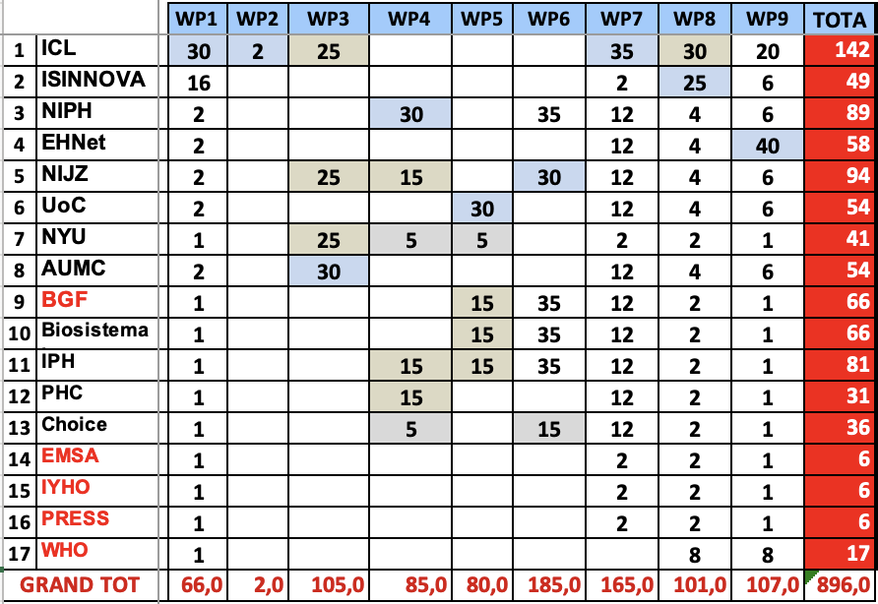

OVERALL BUDGET

