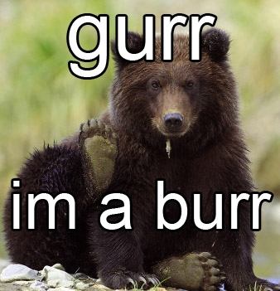


the bear show
dubstep, growling and salmon catching
Saturdays at 3pm

www.icradio.com

