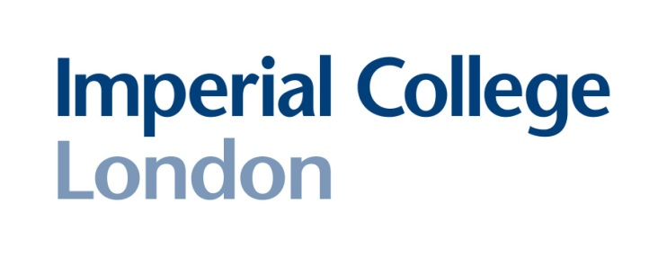

Wednesday 18th July

12:30 pm

Sir Ernst Chain Building
(formerly Biochemistry)
290 Link Lecture Theatre
South Kensington Campus

All welcome

Host: Murray Selkirk

Special Seminar

Dr Omar Qureshi
(University of Birmingham)

“Understanding trans-endocytosis in immune regulation; how to rip stimulatory molecules from antigen-presenting cells”

