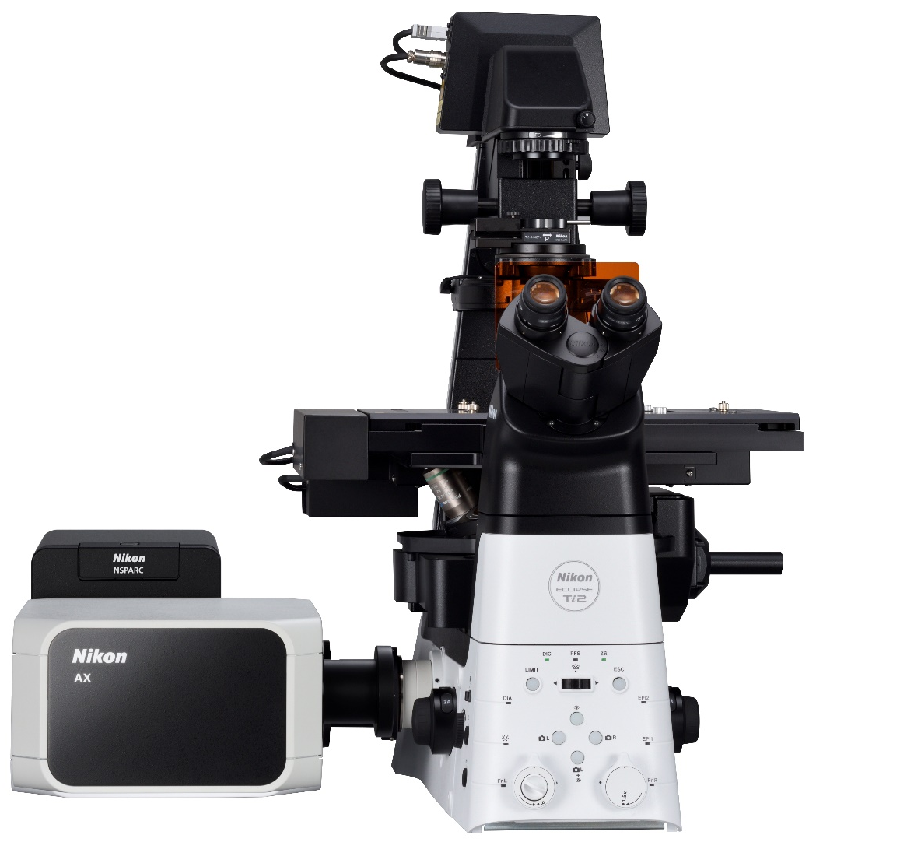

Nikon AX/R with NSPARC
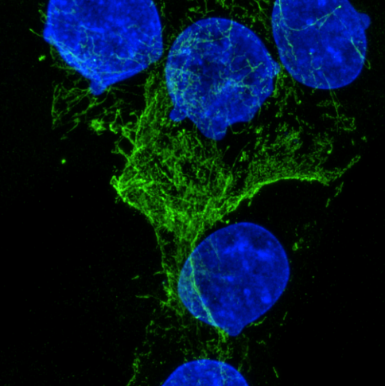
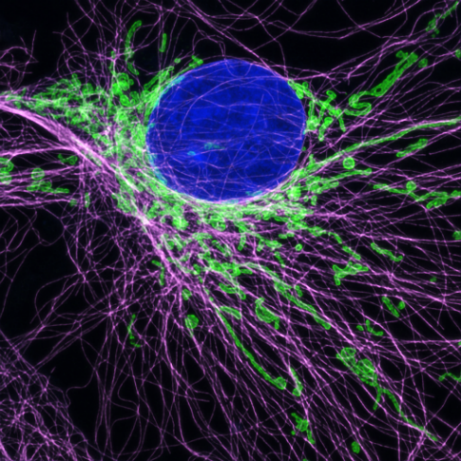
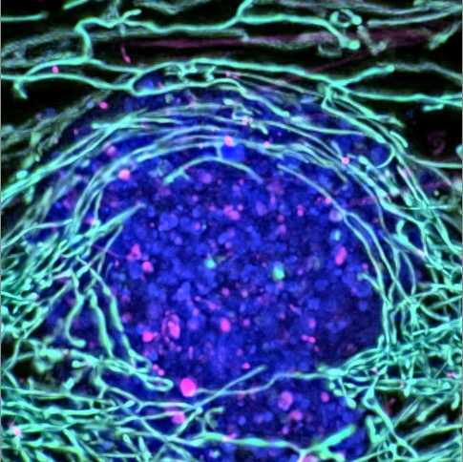
· 2x Increase in resolution · Fast 2K pixels resonant scanning · 8K Galvano · 25mm FOV · Intuitive & Powerful Software [Grab your reader’s attention with a great quote from the document or use this space to emphasize a key point. To place this text box anywhere on the page, just drag it.]

Nikon AX/R – NSPARC Super-Resolution Confocal Microscope Demonstration

Hosted by Imperial College London – Facility for Imaging by Light Microscopy
Nikon Correspondence: Stefan Wojcik (Stefan.Wojcik@Nikon.com)
FILM Correspondence: Volodymyr Nechyporuk-Zloy (v.nechyporuk-zloy@imperial.ac.uk)

Name, Research Group & Contact Details | Research Area and Application | Sample and Fluorophore Information | Main Feature of Interest  (Resolution, speed, other) | Current Imaging Limitations

15th May | Session 1 - 10:00-12:30
15th May | Session 1 - 13:00-16:00
16th May | Session 1 - 13:00-16:00
17th May | Session 1 - 13:00-16:00
18th May | Session 1 - 10:00-12:30
18th May | Session 1 - 13:00-16:00
19th May | Session 1 - 10:00-12:30
19th May | Session 1 - 13:00-16:00
22nd May | Session 1 - 10:00-12:30
22nd May | Session 1 - 13:00-16:00

23rd May | Session 1 - 10:00-12:30
23rd May | Session 1 - 13:00-16:00
24th May | Session 1 - 10:00-12:30
24th May | Session 1 - 13:00-16:00


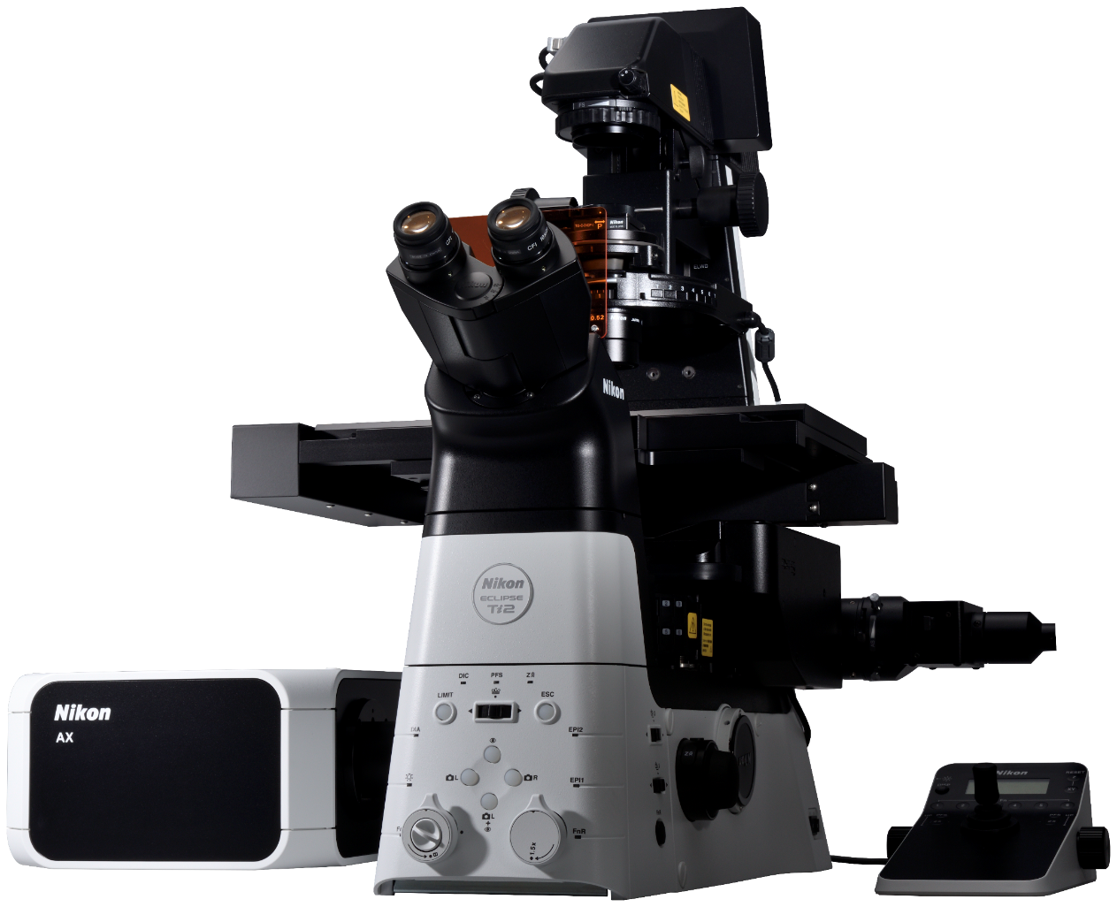
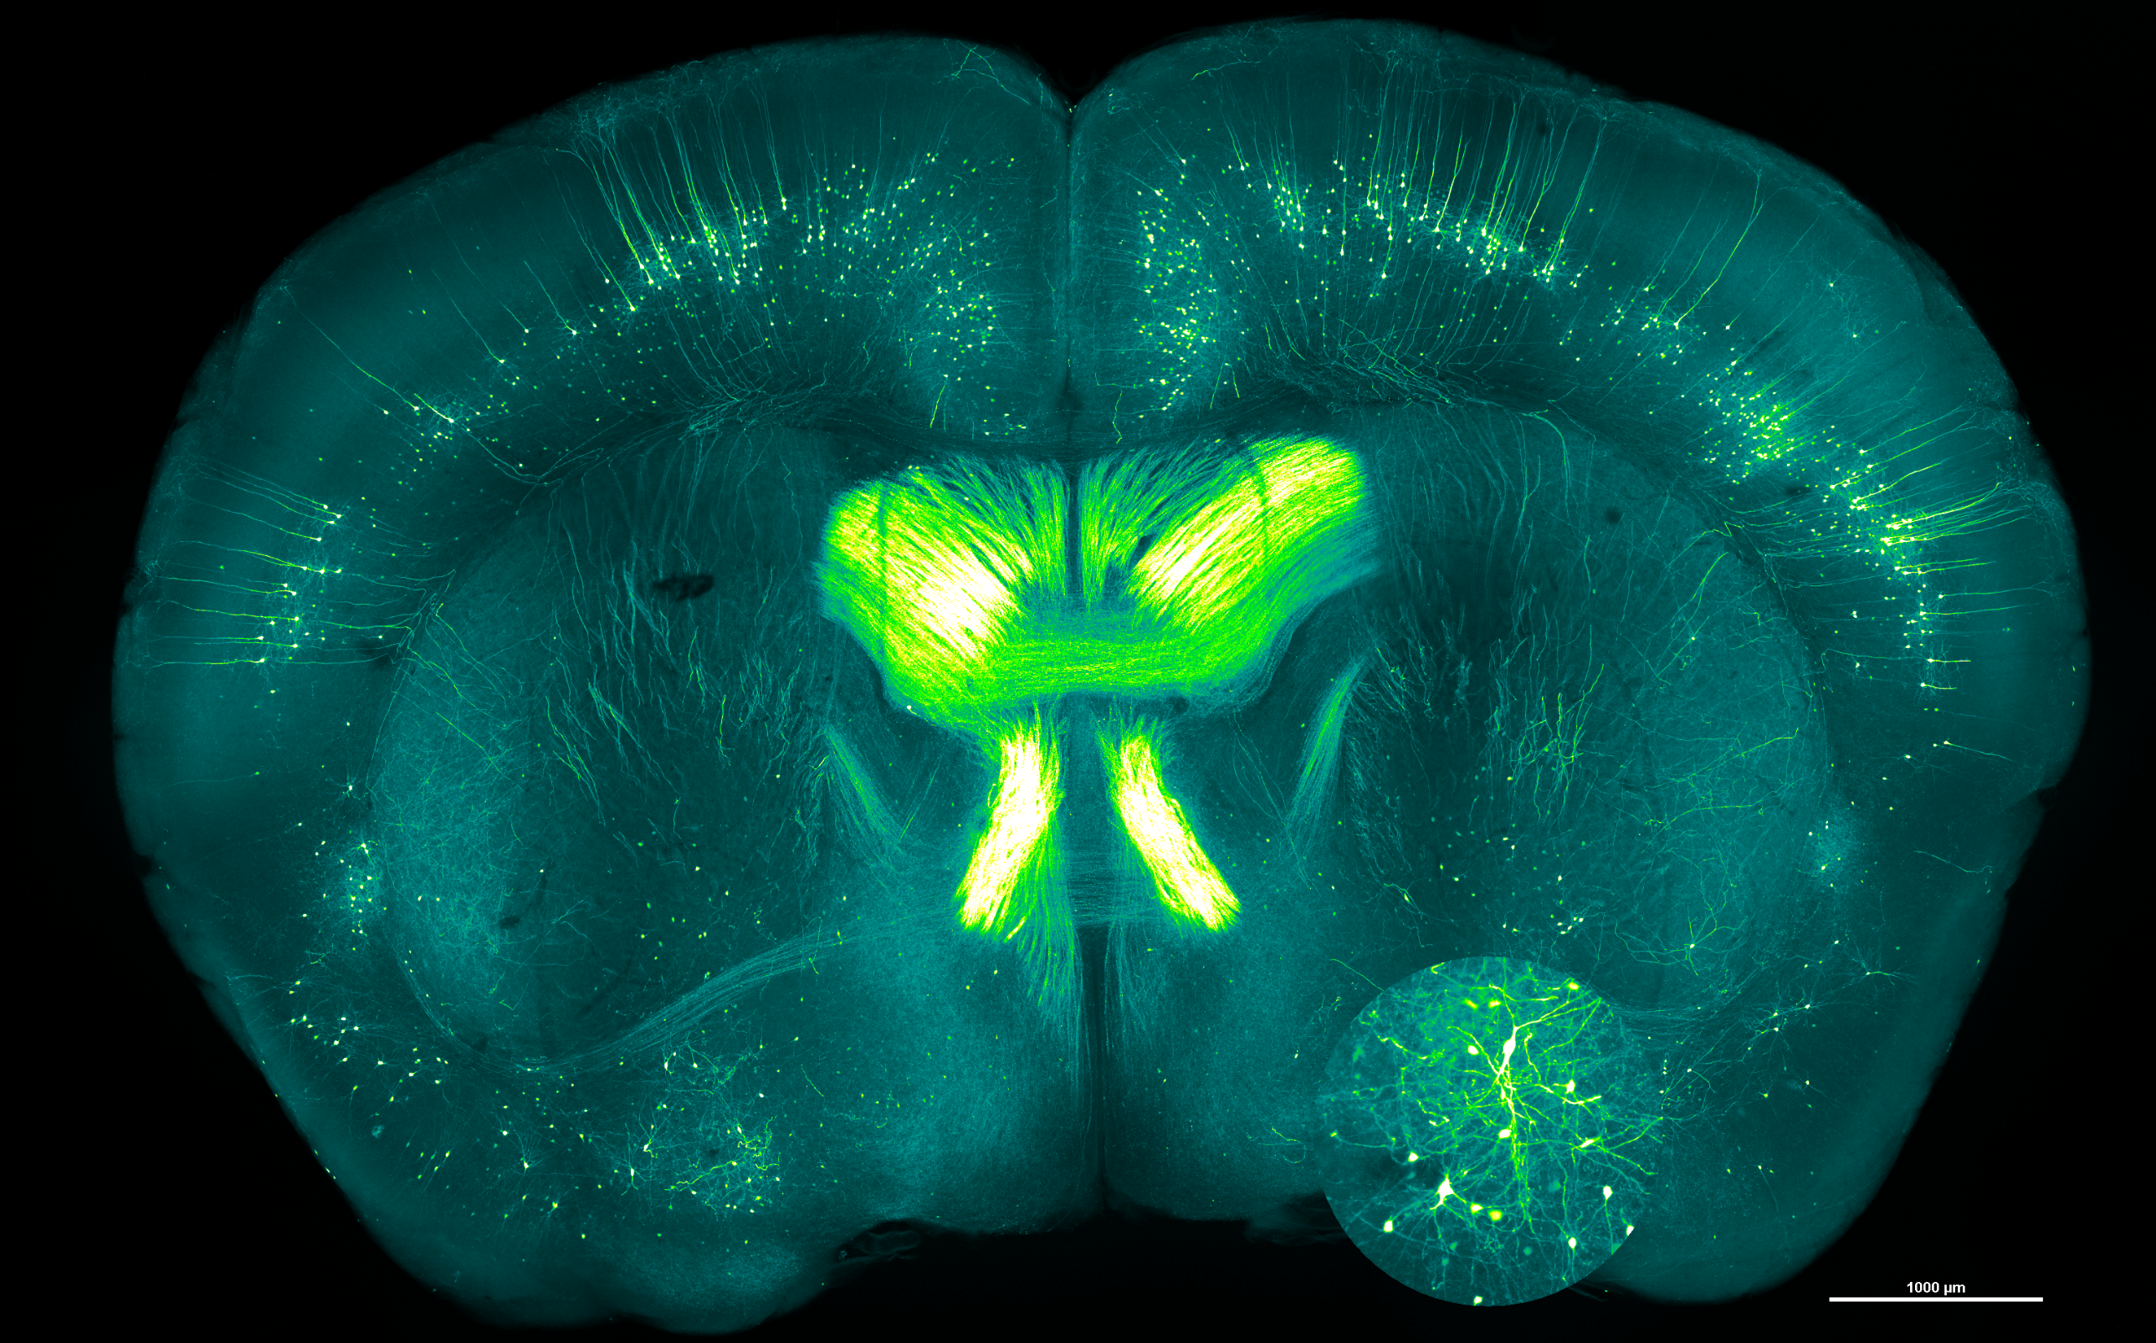

AX opens up to Super Res!
Mouse brain collected at 8192 x 8192 pixels with 25mm FOV , Plan APO 4x, NA 0.2 objective lens

